**Build a Custom Docker Image**

Prerequisites:

* Docker must be installed on your system.

**Step 1:** Clone Git repository

* First, clone the Git repository on a Docker host using the command below:

git clone <https://github.com/Anuj1990/Docker.git>

**Step 2:** Docker Build

* Then, proceed with the docker build command to build a custom docker image.

cd Docker

dockerbuild -t phpcode . -f Dockerfile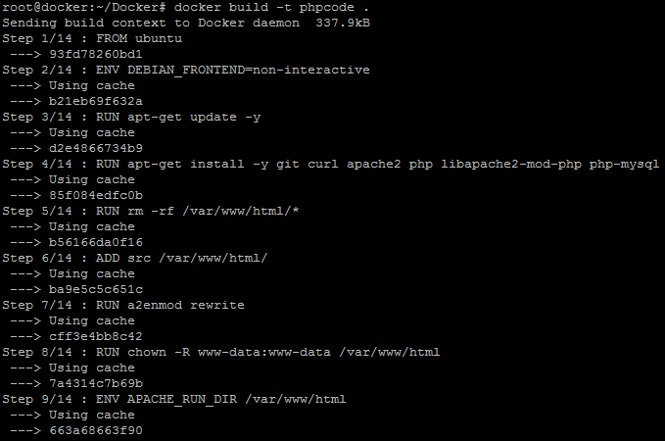

* Once the image is built, check the image using docker run command and then run it to initialize custom container on Docker host.

docker images

docker run -d --name phpcode -p 80:80 phpcode

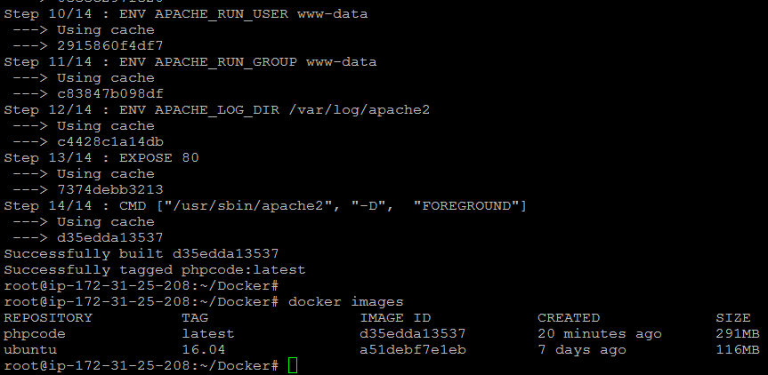

* Once the container is up and running, validate the connectivity using the **curl** command to see if **php code** is running on port 80 or not.